UAT Sign Off Document

Microsoft® Office Enterprise Project Management Solution
UAT Sign-off Document



AstroWix Corporation
39510 Paseo Padre Parkway, Suite 290, Fremont CA 94538, USA
Phone: +1 866 EPM OPM3, Fax: +1 510 791 1111
Email: info@astrowix.com

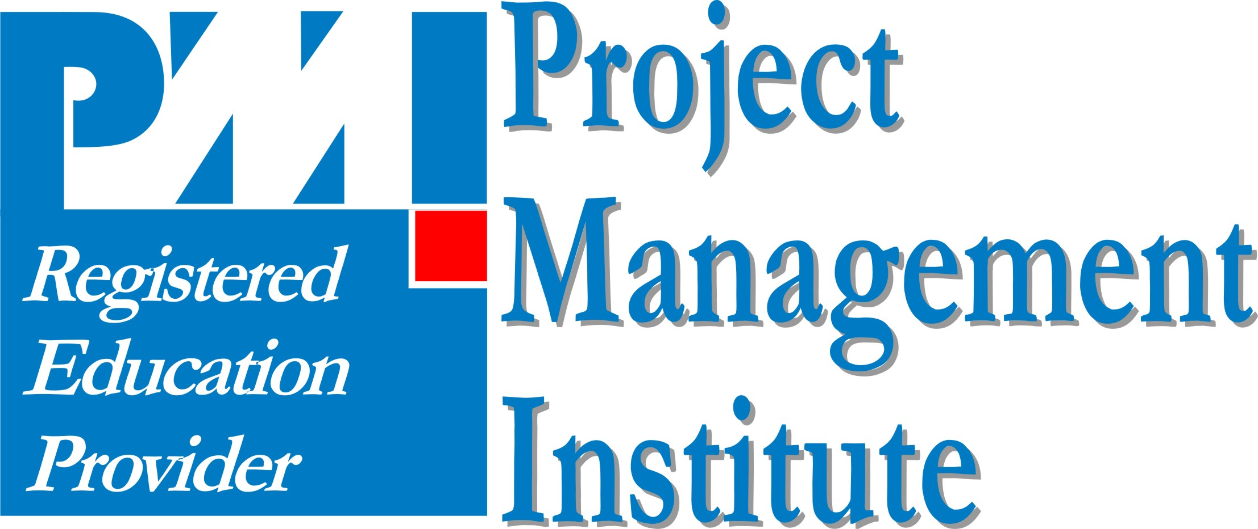

AstroWix India Project Solutions Pvt. Ltd.
Delhi NCR Office
A-53, Sector 16
Noida 201 301, INDIA
Phone: +91 120 431 5760, Fax: +91 120 431 5766
Email: info@astrowix.com
Bangalore Office
484, II Cross, 25th Main
BTM Layout II Stage
Bangalore - 560 076, INDIA
Phone: +91 80 2678 5916
Email: info@astrowix.com

Table of Contents

UAT Sign-off Document 1
Introduction 3
Solution Validation 3
Scenarios 4
Sign-off Sheet 10

Introduction
The purpose of this document is to provide specific scenario(s) that can be used to validate the requirements within scope while performing the user acceptance test of EPMS

Solution Validation
INDEX
A | Feature made available in the current solution
C | Feature made available in the current solution but customized/ tailored/ configured w.r.t. [Client Name]
R | Feature not available in the current solution. Functionality created for [Client Name]
I | Interface with an external application configured to meet the requirement
P | Feature not available in the current solution, customization not suggested due to obvious reasons
X | Out of scope as functionality not available, or requires a Software add-on/ customized development effort
OS | Process/PM related requirement, Out of scope by default

Scenarios

S No. | Requirement Description | Achieved Trough
1. | Centralized Project Plan Repository. | A
Solution Approach
Project Plan created by Project Manager and published to the Enterprise Server that is accessible to all authorized users.
Test Scenario
Senior Executive logs in to Project Web Access and views all Projects.

S No. | Requirement Description | Achieved Trough
2. | Project information in the EPMS should be subject to Role Based Access. | C
Solution Approach
Task Owners can only view the task and project where they are assigned, Project Manager can view all the information of project.
Test Scenario
- Project Manager can view the projects information of his /her Projects.
- Respective Task owner is able to update his/her assignment
- Project Manager is able to restrict visibility of documents in Document Libraries

S No. | Requirement Description | Achieved Trough
3. | The EPMS should allow the Project Manager to view Category, Projects Priority and Market-wise view. | C
Solution Approach
Projects are grouped in Category view to provide a summarized list of Projects Priority-wise and Market-wise
Test Scenario
Project Manager logs into PWA and can view listing by applying Category view.

S No. | Requirement Description | Achieved Trough
4. | The EPMS should allow the Project Manager to view Project Detail in terms of planed vs actual on Detail activities and Major Milestone, in a Project Plan. | C
Solution Approach
Project Managers can view summarized status of percentage complete, planed vs actual of Task, Summary Tasks and Milestone.
Test Scenario
Project Manager logs into PWA and open a Project Plan to view Task Detail View, Task Top-Level and Milestone Status view with Status Indicators.

S No. | Requirement Description | Achieved Trough
5. | The EPMS should be able view the Resource Assignments. | C
Solution Approach
Each resource in the EPMS would be mapped according to their Department
Test Scenario
Project Manager is able to view Resource Assignments in EPMS.

S No. | Requirement Description | Achieved Trough
6. | The EPMS should provide Task Owners to view of upcoming tasks for the current time period enhancing focused visibility and prioritization | A
Solution Approach
The My Task pane of Project Web Access will display the window of 30 days activities assigned to the logged-in resource
Test Scenario
- The Team Member is able to view current assignments as well as all assignment.
- Team Member is able to update the progress of his/her assignment using Project web Access.
- Team Members can link – Issues, Risks and Documents with their Tasks/Project Tasks.

S No. | Requirement Description | Achieved Trough
7. | EPMS should support online collaboration between all stakeholders around Activities, Issues, Risks, Team Discussions, Tasks, Deliverables and Documents specifically to a Project. | A
Solution Approach
A Windows SharePoint Services site would be created for each project published to the EPMS server.
Test Scenario
Project Manager/Task Owners can log in to the Project Workspace of the respective project using Project Web Access

S No. | Requirement Description | Achieved Trough
8. | Attaching Multiple document deliverables against Projects/Activities' which are editable in real time manner be supported by EPMS. | A
Solution Approach
The Windows SharePoint Services component of the EPMS allows for attaching documents to any activities.
Test Scenario
Task Owner and Project Managers logs into Project Web Access and attaches multiple documents, files/ deliverable to his/her task assignment.

S No. | Requirement Description | Achieved Trough
9. | The EPMS should support the storing and version management of project related documents and document templates at a central location. | A
Solution Approach
The Windows SharePoint Services component would be used to create project document libraries and versions of the documents will be automatically maintained on the server.
Test Scenario
Program Manager, Project Manager is able to choose a certain document library and upload a document to it using Project Web Access

S No. | Requirement Description | Achieved Trough
10. | The EPMS should encourage and provide Enterprise Project Templates. | C
Solution Approach
Enterprise Project Template made available.
Test Scenario
Project Manager logs into Project Professional and is able to create a new project plan using an existing Enterprise Project Template.

S No. | Requirement Description | Achieved Trough
11. | The EPMS should support saving multiple baselines and preserving previous ones for comparison | A
Solution Approach
The project manager can save up to 10 more baselines over and above the original baseline.
Test Scenario
Project Manager opens the active Project in Project Professional 2007 and is able to set an additional baseline.

S No. | Requirement Description | Achieved Trough
12. | The EPMS should be able to provide for setting up of alerts and notifications against upcoming and overdue activities. | A
Solution Approach
EPMS is configured in such a way that the Task Owners will get the notifications of tasks overdue and to-do list items in their dashboard.
Test Scenario
Task owner logs in to Project Web Access need to configure alerts and reminder using Personal Setting option, will get the notifications on upcoming as well as over due activities.

S No. | Requirement Description | Achieved Trough
13. | Major Milestone Report and Status of Milestones across Projects should be available. | C
Solution Approach
Reporting Services are used to design Customized Reports based on [Client Name] requirements.
Test Scenario
Level Executives logs to PWA and select Customized Reoprts option to get redirected to ReportServer’s Reports zone; there they can view customized reports.

S No. | Requirement Description | Achieved Trough
14. | Shared Site created for Non Project users. | C
Solution Approach
Top level Windows Share Point Services site created for each non project users to view the Organization Announcements, Thought of Day and Best practice Documents.
Test Scenario
Authenticate Users are able view the top level site using [Put the Site URL].

S No. | Requirement Description | Achieved Trough
15. | The end-user training conducted for Project Server Administrators, Project Managers and Task Owners on specific areas of user-MS Project 2007 and EPMS interfacing. | A
Solution Approach
The training focus on the features to be used by EPMS.
Test Scenario

Sign-off Sheet

This UAT is hereby approved as follows:

Name: _______

Role:

Company Stamp/ Seal
Signature:

Date: _______

Name: _______

Company Stamp/ Seal

Role:

Signature:

Date: _______

Name: _______

Company Stamp/ Seal

Role:

Signature:

Date: _______

Name: _______

Company Stamp/ Seal

Role:

Signature:

Date: _______

Name: _______

Company Stamp/ Seal

Role:

Signature:

Date: _______

Name: _______

Company Stamp/ Seal

Role:

Signature:

Date: _______

Name: _______

Company Stamp/ Seal

Role:

Signature:

Date: _______

